*Conclusion*

**TASK 2.8**

Content Auditing

By: Minal Bombatkar

Conducting a content audit on the "sweetescapeyoga" website was helpful in gaining some perspective on the overall process and services the company offers to its customers making yoga experts advice more accessible i.e. through virtual yoga option and affordable.  
  
I tried this website on desktop as well as on a mobile phone. Site design is responsive and typographical good choose. This website focus on relevant content is notable in the structured layout.  
  
Overall, I found the content to be useful and engaging, however, there are a few things the site could improve upon. The minimal usage of tabs for the site’s main navigation is required, and they will be organised into a menu and submenu category versus all the menus on the top navigation.  
  
All in one I found this website is useful for yoga seekers. Only some pages are disorganized.

[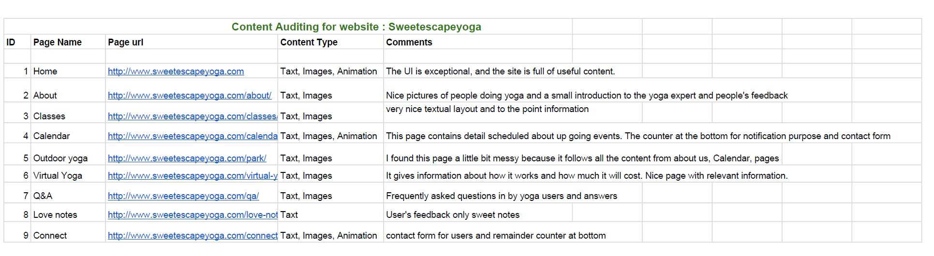](https://docs.google.com/spreadsheets/d/1zHXU547l9F_akjDuC752ERAKVcZ93wLtOP7x3Bwy7sE/edit?usp=sharing)

#Click on image to view the google sheet.